

A Project Report

On

Tourism Management System

By

Rutuja Koli

B.E

Batch :- 2020 – 4965

Center :- Pune, Chinchwad

Under the Guidance of,

Jayant V.

Technical Trainer

EduBridge

(School of coding)

**Introduction:**

The Main objective of this Travel & Tourism project is to make the travel easy and comfortable for the users right from booking Hotels and Rooms, finding the routes and buses to till the booking of the tickets, also providing food and have option to choose different packages. In this project, we have two modules, Admin, and user.

Admin in this Travel & Tourism Management System project will log in with the default username and password and admin has authority to add packages, hotels, room, food, add the bus routes and add the discount. Furthermore, Admin will also modify and delete any of services as per requirement .

Finally, the user will register and log in and the find the package, hotel, room, food, transport. After selecting the information user will be headed to modify or delete any of the service which he want to. Then after selection done by user he will be redirected for payment and after successful payment the booking confirmation will be shown.

**Software Requirements:**

Front end: Java/J2EE technologies (Servlet, JSP), HTML, CSS, JDBC.

Back end: MySQL.

Middleware/Server: Apache Tomcat v 7.0

IDE: Eclipse IDE for Java EE Developers

Browser: Best result on Google Chrome

Operating System: Window 7

**Data Dictionary:**

**Database name: tourism**

CREATE TABLE `bookfood` (

`type` varchar(45) NOT NULL,

`foodName` varchar(45) NOT NULL,

`foodCost` varchar(45) NOT NULL,

`quantity` varchar(45) NOT NULL,

`totalCost` int(45) NOT NULL,

`email` varchar(45) NOT NULL,

`packagename` varchar(45) NOT NULL,

`place` varchar(45) NOT NULL

)

ENGINE=MyISAM DEFAULT CHARSET=latin1;

INSERT INTO `bookfood` (`type`, `foodName`, `foodCost`, `quantity`, `totalCost`, `email`, `packagename`, `place`) VALUES

('Non-Veg', 'Butter Chicken', '15', '3', 45, 'luffy', 'green building', 'missori'),

('Non-Veg', 'Chicken Biryani', '10', '1', 10, 'luffy', 'green building', 'missori');

CREATE TABLE `bookpackage` (

`id` int(3) NOT NULL,

`packagename` varchar(45) NOT NULL,

`place` varchar(45) NOT NULL,

`packageCost` varchar(45) NOT NULL,

`days` varchar(45) NOT NULL,

`noofPersons` varchar(45) NOT NULL,

`totalcost` int(45) NOT NULL,

`email` varchar(45) NOT NULL

)

ENGINE=MyISAM DEFAULT CHARSET=latin1;

INSERT INTO `bookpackage` (`id`, `packagename`, `place`, `packageCost`, `days`, `noofPersons`, `totalcost`, `email`) VALUES

(1, 'green building', 'washington', '30', '1', '1', 30, 'nikesh@gmail.com'),

(2, 'Snow Time', 'NC', '20', '2', '1', 20, 'nikesh@gmail.com'),

(1, 'waterfall', 'nc', '20', '1', '1', 20, 'sai@gmail.com'),

(2, 'Snow Time', 'NC', '20', '2', '1', 20, 'sai@gmail.com'),

(1, 'Snow Time', 'NC', '20', '2', '10', 200, 'nikesh2804@gmail.com'),

(3, 'green building', 'missori', '30', '2', '1', 30, 'nikesh@gmail.com'),

(1, 'green building', 'missori', '30', '2', '2', 60, 'luffy');

CREATE TABLE `bookroom` (

`hotelName` varchar(45) NOT NULL,

`roomType` varchar(45) NOT NULL,

`roomSize` varchar(45) NOT NULL,

`roomCost` int(45) NOT NULL,

`roomDate` varchar(45) NOT NULL,

`email` varchar(45) NOT NULL,

`packagename` varchar(45) NOT NULL,

`place` varchar(45) NOT NULL

)

ENGINE=MyISAM DEFAULT CHARSET=latin1;

INSERT INTO `bookroom` (`hotelName`, `roomType`, `roomSize`, `roomCost`, `roomDate`, `email`, `packagename`, `place`) VALUES

('swagath', 'AC', 'Single', 100, '2017-02-23', 'luffy', 'green building', 'missori'),

('Taj', 'AC', 'Double', 300, '2017-02-15', 'nikesh2804@gmail.com', 'Snow Time', 'NC'),

('Taj', 'AC', 'Double', 300, '2017-02-16', 'nikesh2804@gmail.com', 'Snow Time', 'NC');

CREATE TABLE `booktransport` (

`transportType` varchar(45) NOT NULL,

`vehicleType` varchar(45) NOT NULL,

`vehicleName` varchar(45) NOT NULL,

`vehicleCost` int(45) NOT NULL,

`vehicleDate` varchar(45) NOT NULL,

`email` varchar(45) NOT NULL,

`packagename` varchar(45) NOT NULL,

`place` varchar(45) NOT NULL

)

ENGINE=MyISAM DEFAULT CHARSET=latin1;

INSERT INTO `booktransport` (`transportType`, `vehicleType`, `vehicleName`, `vehicleCost`, `vehicleDate`, `email`, `packagename`, `place`) VALUES

('Car', 'AC', 'sonata sport', 300, '2017-02-17', 'nikesh2804@gmail.com', 'Snow Time', 'NC'),

('Car', 'AC', 'sonata sport', 300, '2017-02-22', 'luffy', 'green building', 'missori');

CREATE TABLE `discount` (

`packagename` varchar (45) NOT NULL,

`discount` varchar(45) NOT NULL

)

ENGINE=MyISAM DEFAULT CHARSET=latin1;

INSERT INTO `discount` (`packagename`, `discount`) VALUES

('green building', '20'),

('waterfall', '10');

CREATE TABLE `food` (

`foodtype` varchar(45) NOT NULL,

`foodname` varchar(45) NOT NULL,

`foodcost` varchar(45) NOT NULL

)

ENGINE=MyISAM DEFAULT CHARSET=latin1;

INSERT INTO `food` (`foodtype`, `foodname`, `foodcost`) VALUES

('Non-Veg', 'Chicken Biryani', '10'),

('Non-Veg', 'Butter Chicken', '15'),

('Veg', 'Gobi', '5');

CREATE TABLE `hotel` (

`hotelName` varchar(45) NOT NULL

)

ENGINE=MyISAM DEFAULT CHARSET=latin1;

INSERT INTO `hotel` (`hotelName`) VALUES

('swagath'),

('taj krishna');

CREATE TABLE `package` (

`id` int(4) NOT NULL,

`packagename` varchar(45) NOT NULL,

`place` varchar(45) NOT NULL,

`cost` varchar(45) NOT NULL,

`days` varchar(45) NOT NULL

)

ENGINE=MyISAM DEFAULT CHARSET=latin1;

INSERT INTO `package` (`id`, `packagename`, `place`, `cost`, `days`) VALUES

(4, 'Snow Time', 'NC', '20', '2'),

(5, 'waterfall', 'nc', '20', '1'),

(7, 'green building', 'washington', '30', '1'),

(8, 'green building', 'missori', '30', '2');

CREATE TABLE `payment` (

`packagename` varchar(45) NOT NULL,

`place` varchar(45) NOT NULL,

`cost` varchar(45) NOT NULL,

`email` varchar(45) NOT NULL,

`cardName` varchar(45) NOT NULL,

`cardNumber` varchar(45) NOT NULL,

`cvv` varchar(45) NOT NULL

)

ENGINE=MyISAM DEFAULT CHARSET=latin1;

INSERT INTO `payment` (`packagename`, `place`, `cost`, `email`, `cardName`, `cardNumber`, `cvv`) VALUES

('green building', 'washington', '27', 'nikesh@gmail.com', 'nikesh', '1234567891523654', '456');

CREATE TABLE `register` (

`name` varchar(45) NOT NULL,

`email` varchar(45) NOT NULL,

`password` varchar(45) NOT NULL,

`mobile` varchar(45) NOT NULL

)

ENGINE=MyISAM DEFAULT CHARSET=latin1;

INSERT INTO `register` (`name`, `email`, `password`, `mobile`) VALUES

('nikesh', 'nikesh@gmail.com', 'sai', '1234567890'),

('sai', 'sai@gmail.com', 'sai', '7894561230'),

('nikesh', 'nikesh2804@gmail.com', '8121343348', '8121343348'),

('luffy', 'luffy', 'luffy', '8794561230');

CREATE TABLE `room` (

`hotelName` varchar(45) NOT NULL,

`roomType` varchar(45) NOT NULL,

`roomSize` varchar(45) NOT NULL,

`roomCost` varchar(45) NOT NULL

)

ENGINE=MyISAM DEFAULT CHARSET=latin1;

INSERT INTO `room` (`hotelName`, `roomType`, `roomSize`, `roomCost`) VALUES

('swagath', 'AC', 'Single', '100'),

('swagath', 'AC', 'Double', '1000'),

('taj krishna', 'Non-AC', 'Single', '15'),

('taj krishna', 'AC', 'Double', '500');

CREATE TABLE `transport` (

`transportType` varchar(45) NOT NULL,

`vehicleType` varchar(45) NOT NULL,

`vehicleName` varchar(45) NOT NULL,

`vehicleCost` varchar(45) NOT NULL

)

ENGINE=MyISAM DEFAULT CHARSET=latin1;

INSERT INTO `transport` (`transportType`, `vehicleType`, `vehicleName`, `vehicleCost`) VALUES

('Car', 'AC', 'sonata sport', '300'),

('Bus', 'AC', 'Bus', '50'),

('Mini-Bus', 'Non-AC', 'Mini-Bus', '50'),

('Bus', 'Non-AC', 'Bus', '30'),

('Mini-Bus', 'AC', 'Mini-Bus', '53');

ALTER TABLE `bookpackage`

ADD KEY `id` (`id`) USING BTREE;

ALTER TABLE `package`

ADD KEY `id` (`id`);

ALTER TABLE `bookpackage` MODIFY `id` int(3) NOT NULL AUTO_INCREMENT, AUTO_INCREMENT=27;

ALTER TABLE `package` MODIFY `id` int(4) NOT NULL AUTO_INCREMENT, AUTO_INCREMENT=12;

**Screenshot:**

1. **HOME:-**

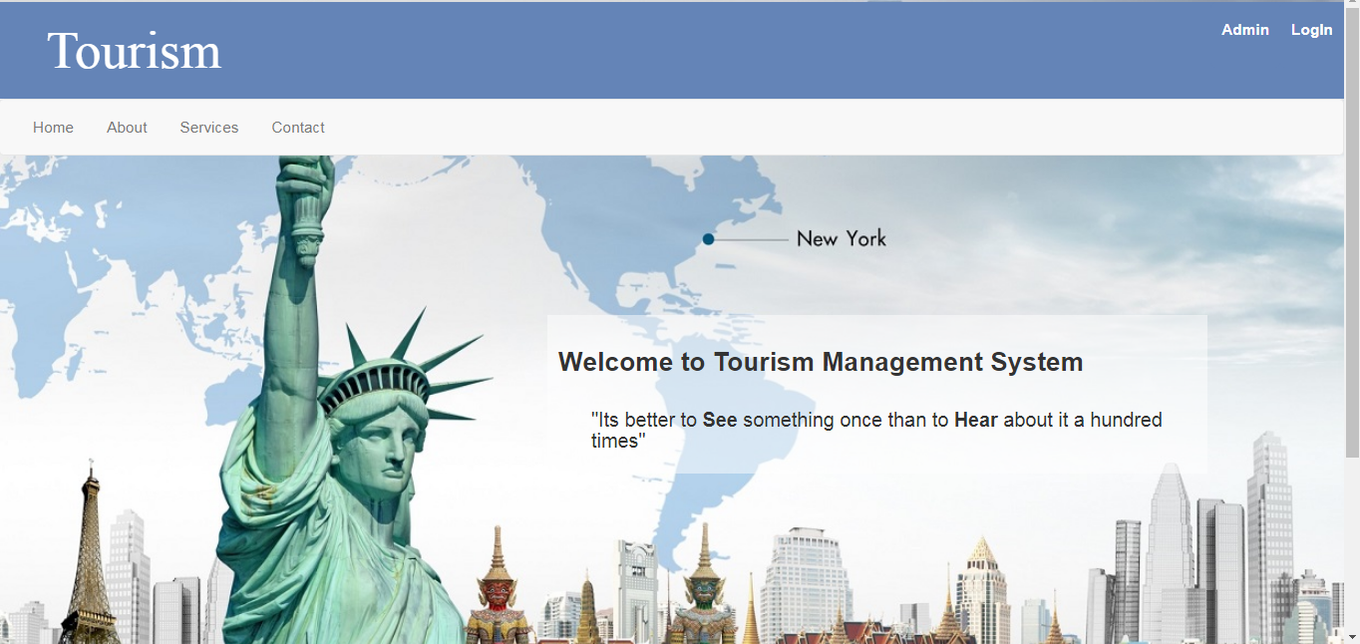

1. 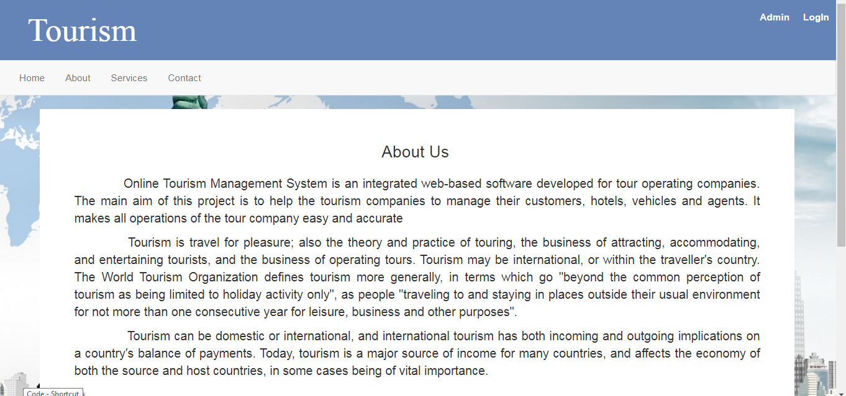**ABOUT US:-**
2. 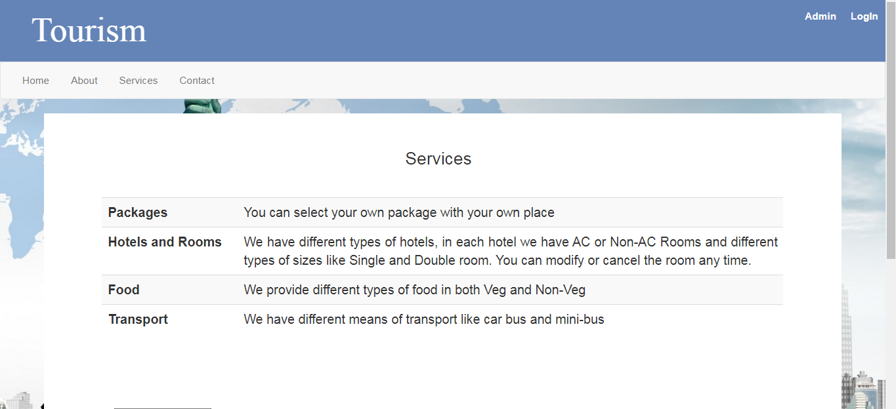**SERVICES:-**
3. **CONTACT US:-**

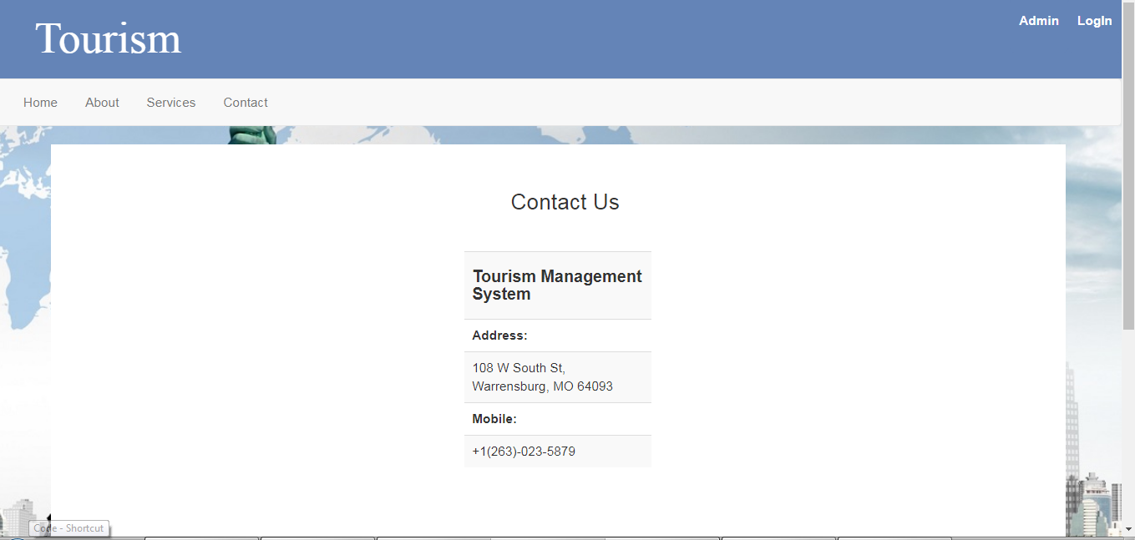

1. **LOGIN:-**

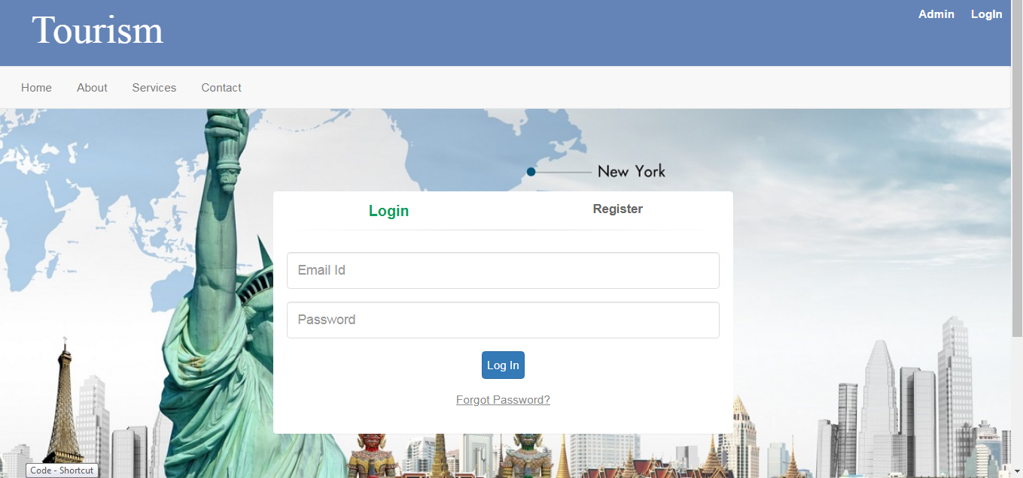

1. 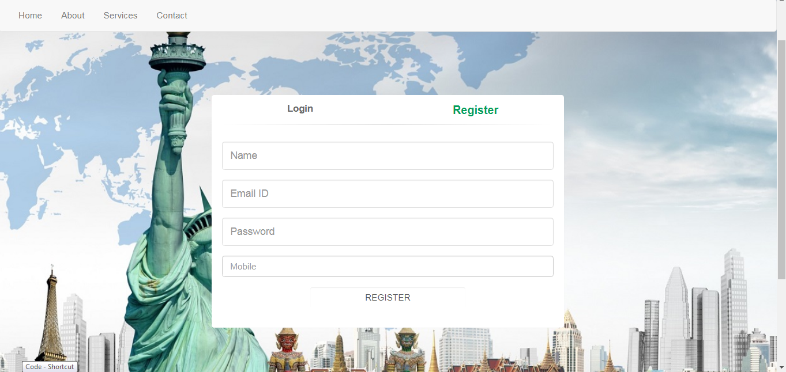**REGISTER:-**
2. **WELCOME:-**

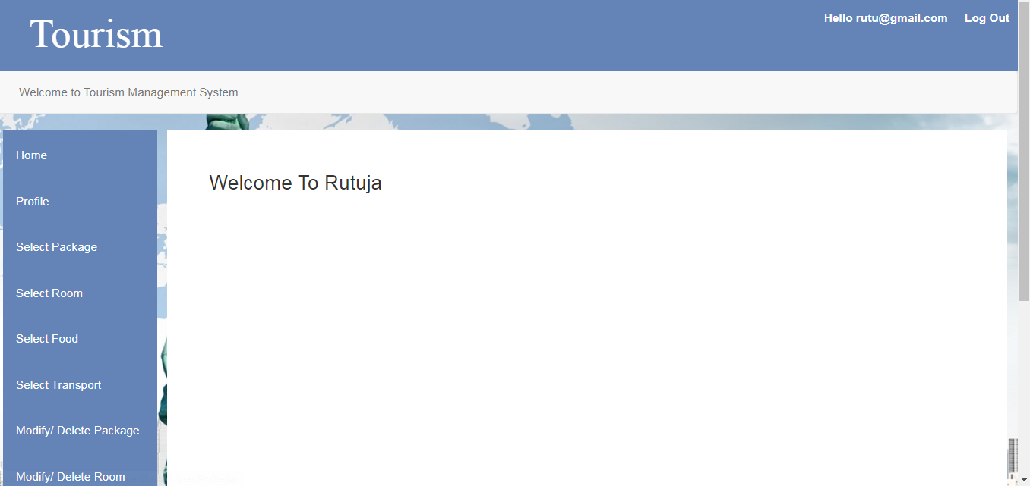

1. **PROFILE:-**

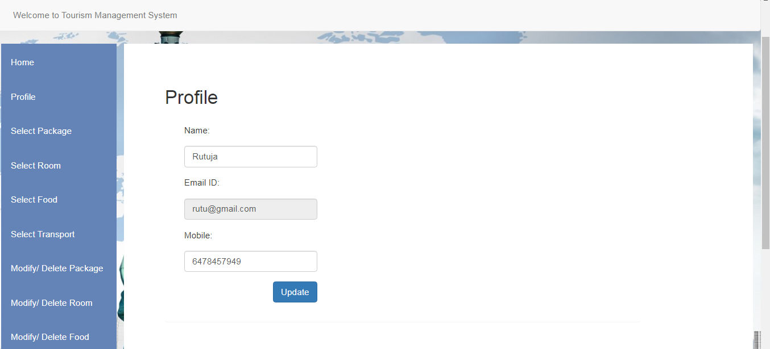

1. **BOOK PACKAGE:-**

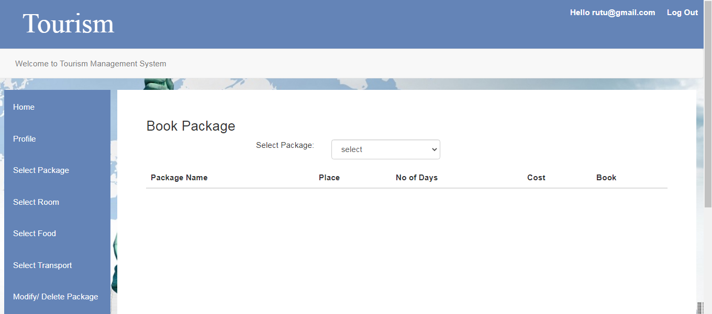

1. **BOOK ROOM:-**

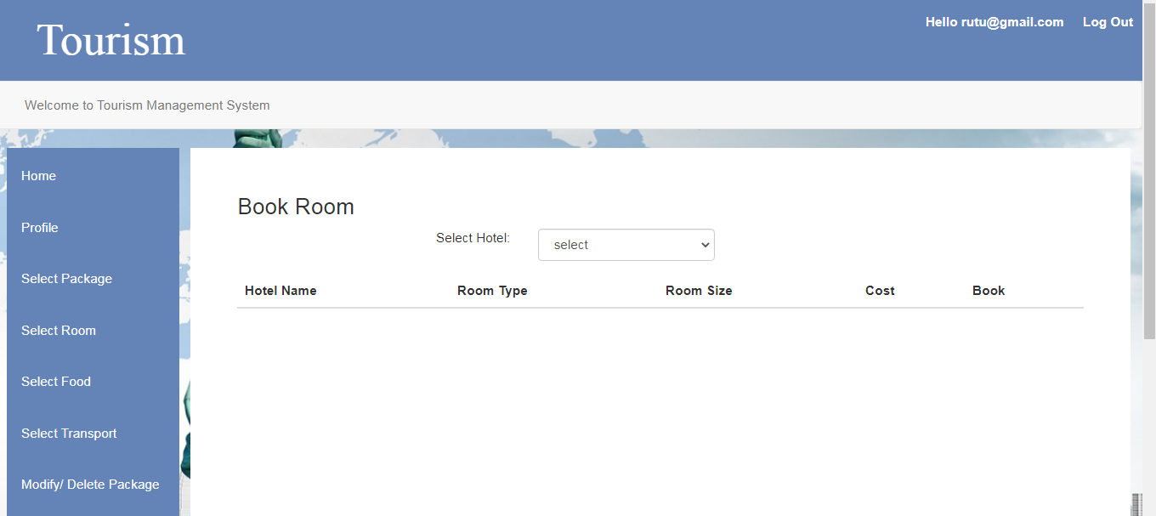

1. 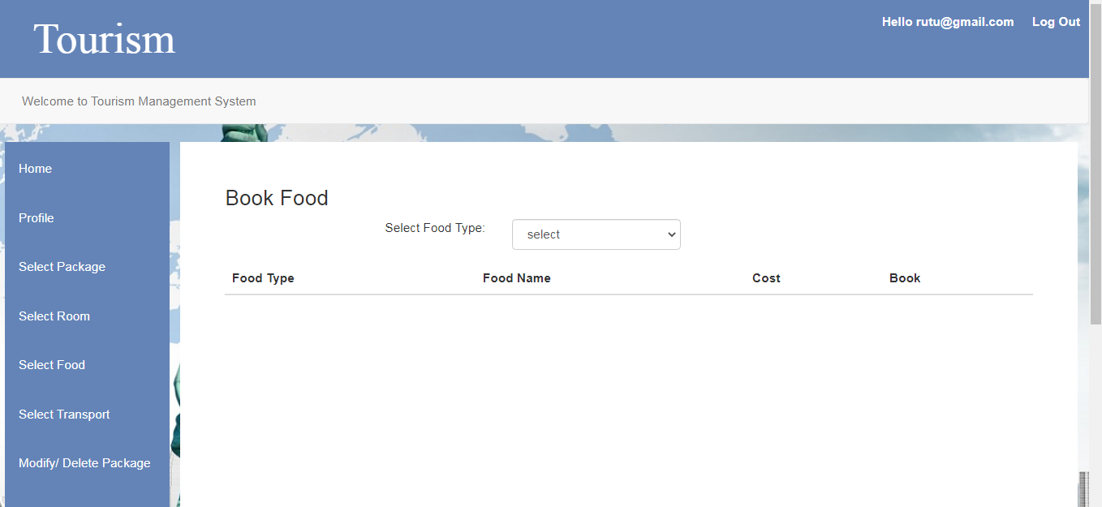**BOOK FOOD:-**
2. **SELECT TRANSPORT:-**

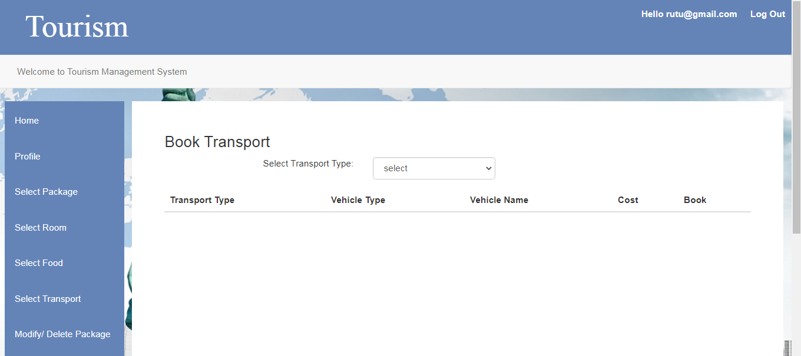

1. **MODIFY/DELETE PACKAGE:-**

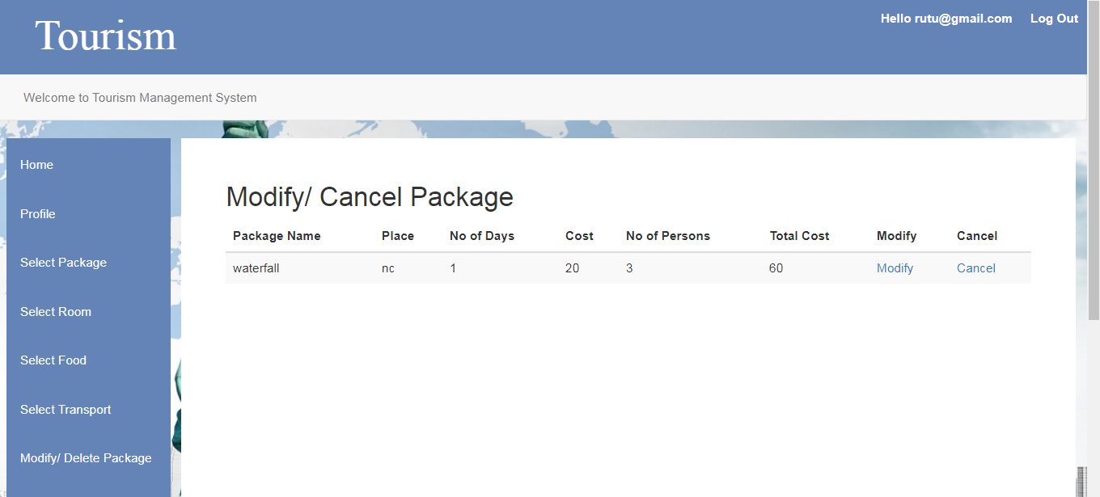

1. **MODIFY/DELETE ROOM:-**

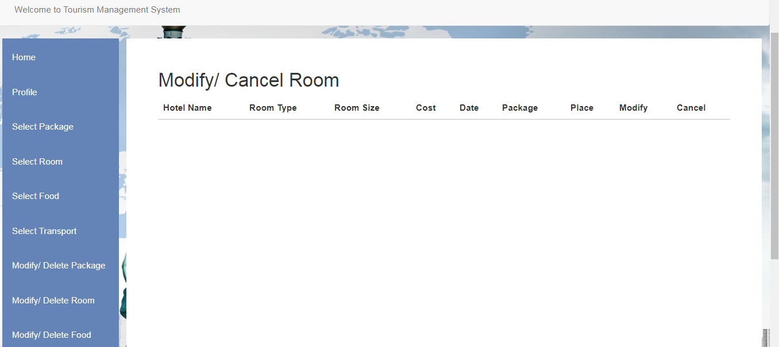

1. 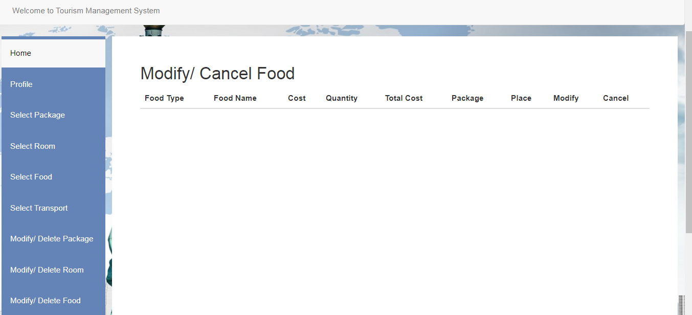**MODIFY/DELETE FOOD:-**

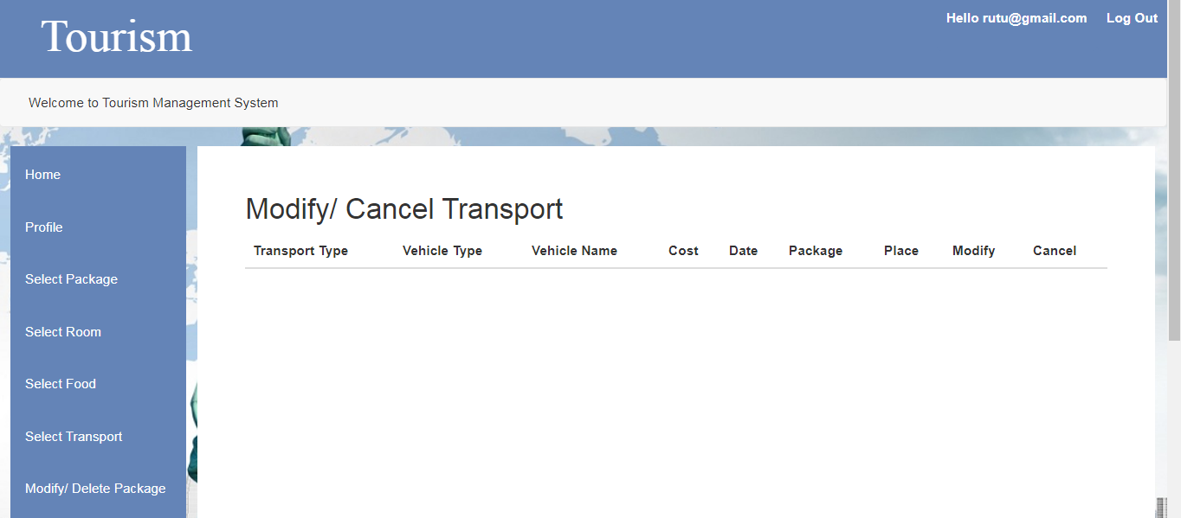

1. **MODIFY/DELETE TRANSPORT:-**
2. **CONFIRMATION DETAILS:-**

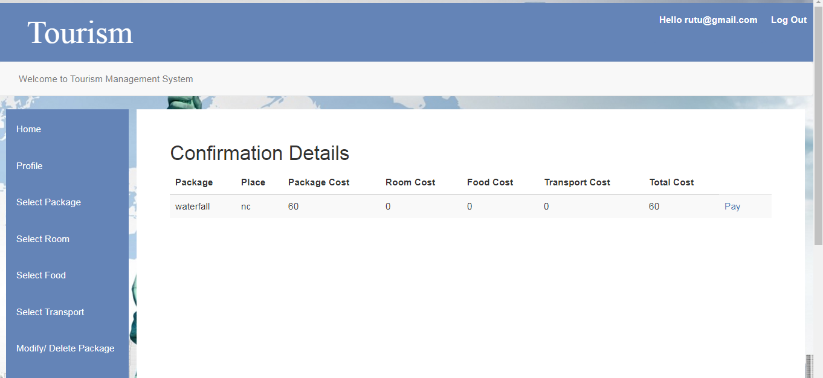

1. 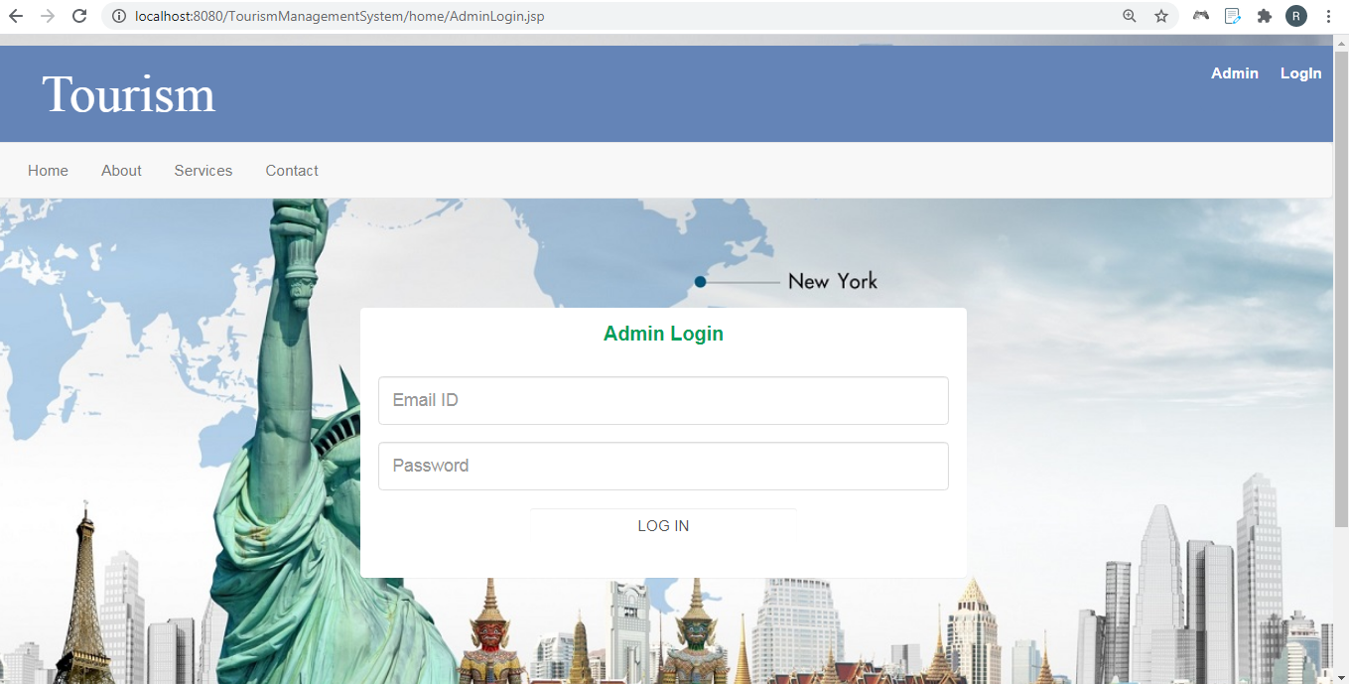**ADMIN LOGIN:-**
2. 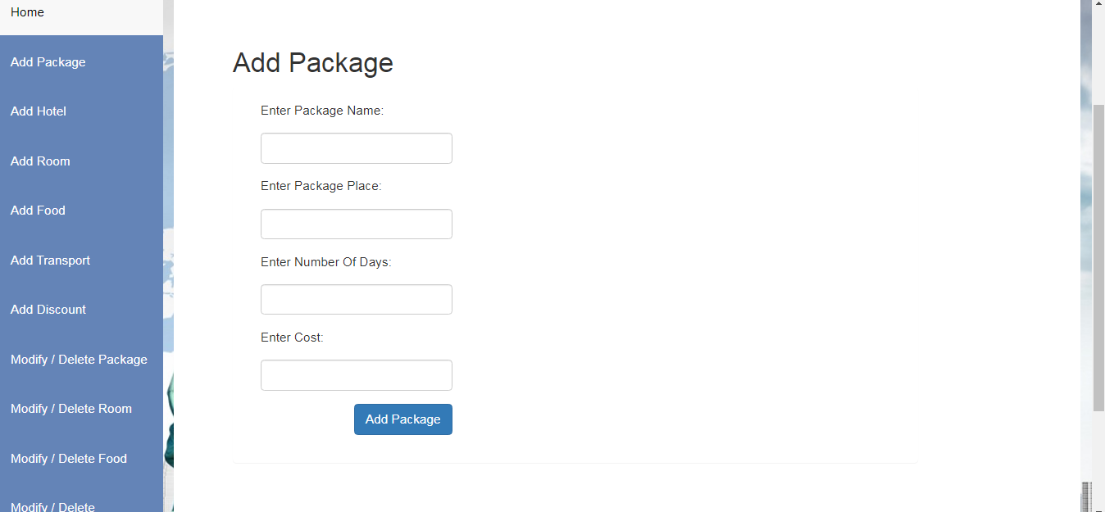**ADD PACKAGE:-**
3. **ADD HOTEL:-**

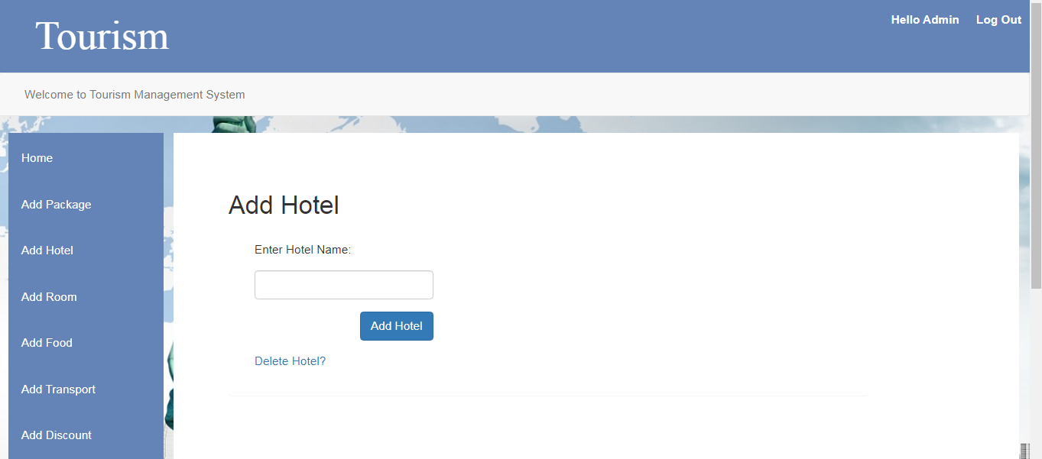

1. 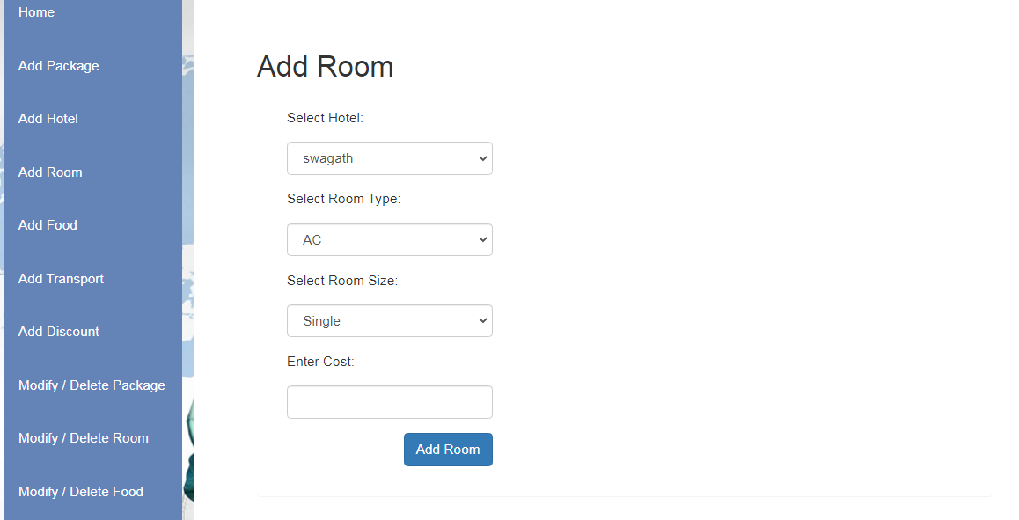**ADD ROOM:-**
2. 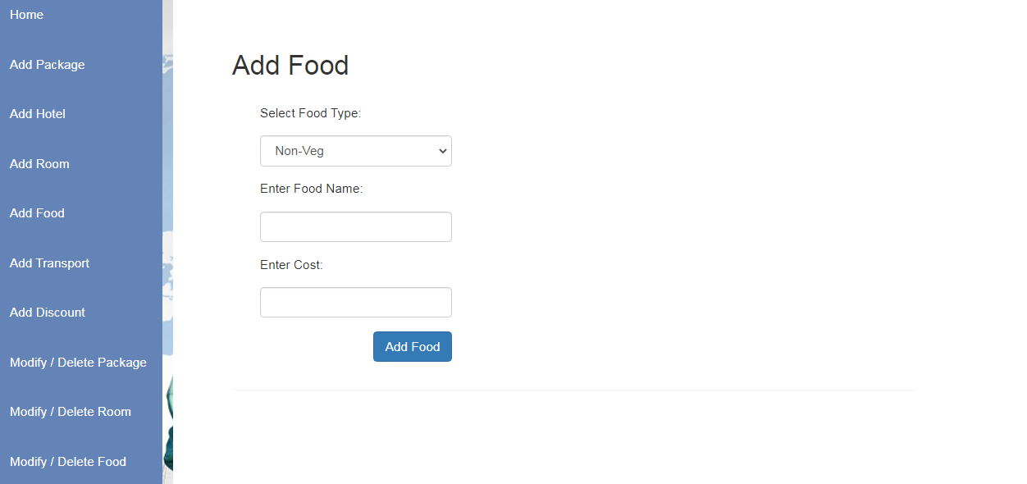**ADD FOOD:-**
3. 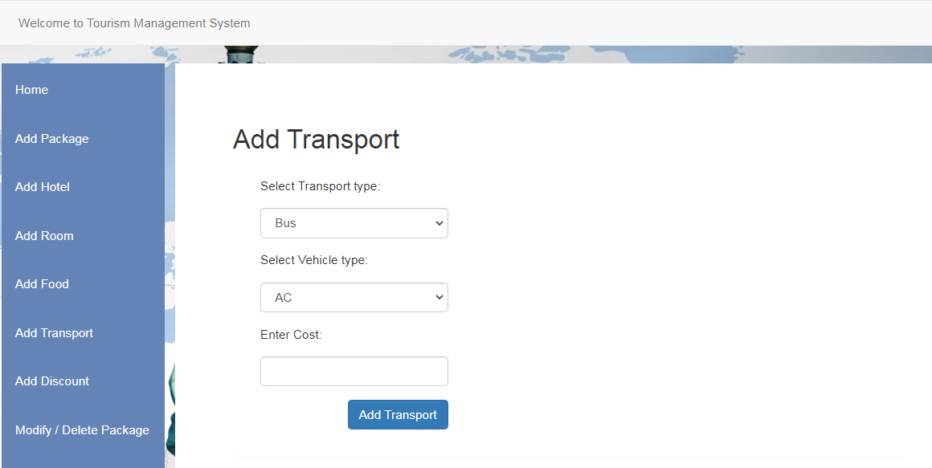**ADD TRANSPORT:-**
4. 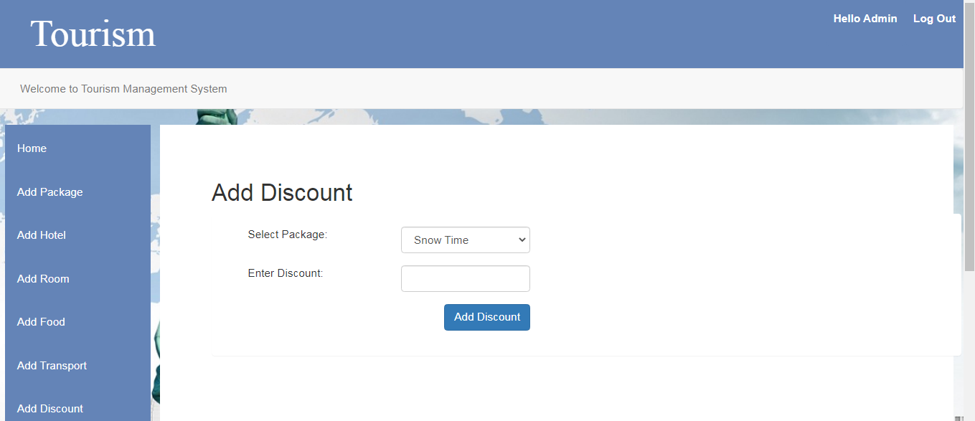**ADD DISCOUNT:-**
5. 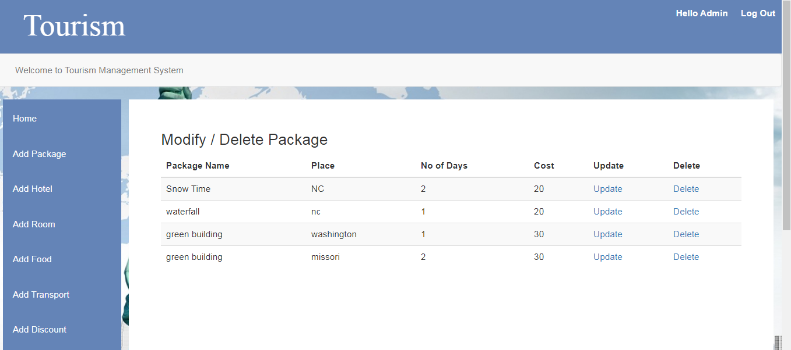**MODIFY/DELETE PACKAGE:-**
6. **MODIFY/DELETE ROOM:-**

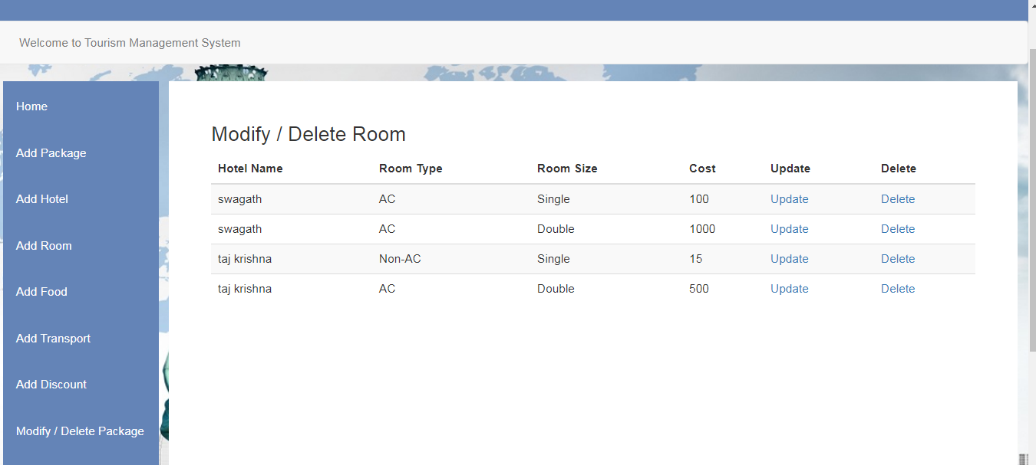

1. 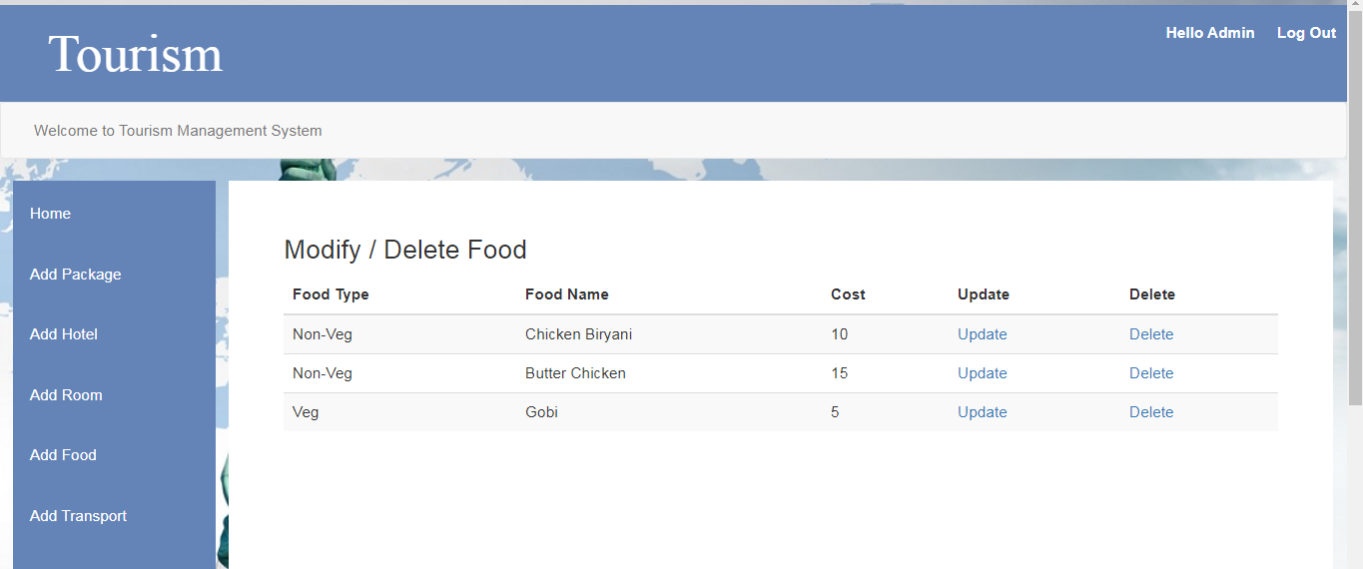**MODIFY/DELETE FOOD:-**

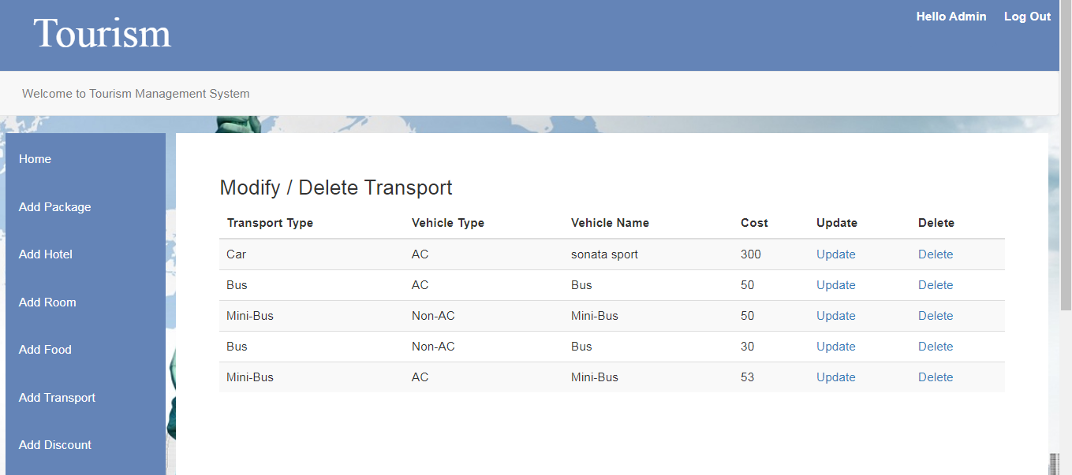

1. **MODIFY/DELETE TRANSPORT:-**
2. **MODIFY/DELETE DISCOUNT:-**

